**ABSTRACT**

My project is based on a simple text editor which will be created using Java Programming Language. It will use some basic concepts of simple Gui.

Basically, a Text Editor is a commonly used application in our lives to write and store data. Text editors differ by their features, in which we try to illustrate a few like saving a file, opening a file, printing a file and other editing options like cut, copy, paste.

I have used Swing library for this Text Editor. This library provides us simple and better Gui application. In addition to Swing library, I have also used Abstract Window Tool Kit library to set the locations of dialog boxes and position the content in it.

**Concepts Used:** Event Listeners, Gui component creations.

**TABLE OF CONTENTS**

Certificate ii

Abstract iii

1. Existing System 1
2. Problem Statement 1
3. Diagrams 1
4. Code Snippets 2
5. Testing 3
6. Conclusion 4
7. References 4

**Existing System:**

I have done this project taking notepad as reference .

I have tried to make a simpler version of Notepad as my project by limiting to certain functionalities to buttons rather keyboard usage such as shortcut keys.

**Problem Statement:**

Creating A Simple text editor with minimum required features to work on any text files.

**Diagrams/ Images:**

Real View:

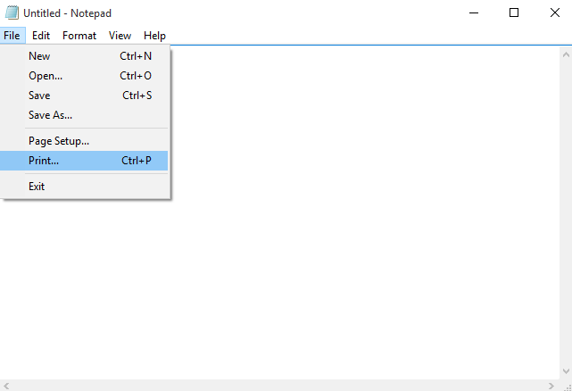

My Text editor View:

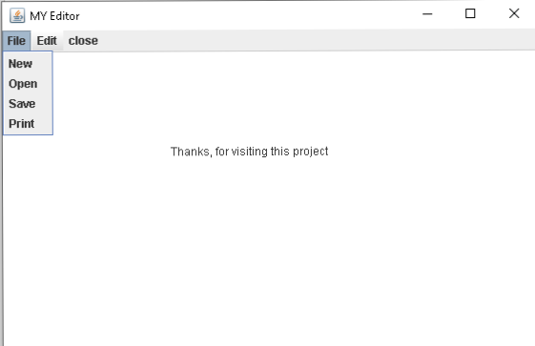

**Code Snippets:**

­­ 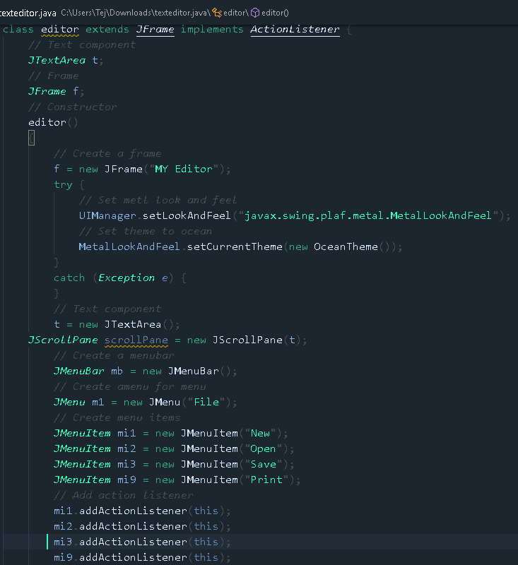

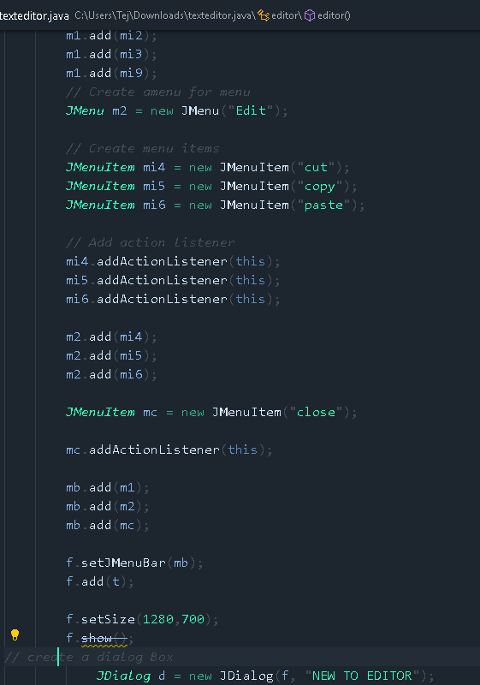

**Testing:**

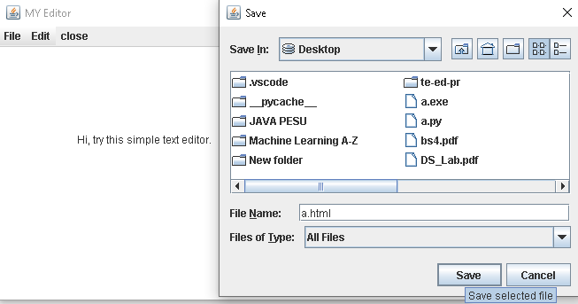

**Conclusion:**

Text Editors are extremely useful in handling the data in various ways.

Editors act as a interface between us and data to perform operations on data .

They have been so advanced in recent days started using Artificial intelligence to check for intellisense, linting,etc.

Text Editors are being improved better and such that they prove us wrong every time we think they cannot be developed any more.

**References:**

Java Swing, Second Edition by James Elliott

Java Swing Tutorials, Herong Yang.